# PE18 – Radio Buttons and UX

Using the attached EditPerson project, edit the EditPerson form to have the following design:

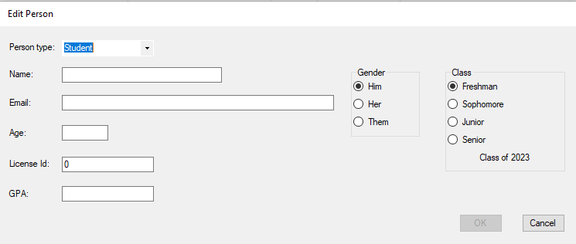

1. Follow the 8 steps starting at line #100 in the PersonEditForm() constructor to modify the form as above. A form can only have 1 selected RadioButton at a time, but we need to have 2: one for Gender and one for Class. To accomplish this, you added the RadioButton controls onto GroupBox controls, which then act like mini-forms.
2. In the constructor public PersonEditForm( Person person, Form ownerForm )
   1. Refer to "Windows Forms Controls" in myCourses for how to add the code to set the Event Handler delegate method to ClassRadioButton__CheckedChanged for the CheckedChanged event of the 4 class-related Radio Buttons
   2. Check the gender radio button based on person.eGender. Default to "Them" if a new person (ie. person.name == null). Check the button by setting radioButton.Checked = true.
   3. If it's a Student object, then check the class radio button based on student.eCollegeYear. Default to "Senior".
3. Write the ClassRadioButton__CheckedChanged method with the following signature:

private void ClassRadioButton__CheckedChanged(object sender, EventArgs e)

sender is a RadioButton object

Define a RadioButton variable rb pointed to sender. (You will have to explicitly cast sender to type RadioButton).

Check if rb.Checked is true.

If so, then set this.classOfLabel.Text to match the Radio Button that is checked.

For example if seniorRadioButton is checked, then this.classOfLabel.Text = "Class of 2021"

1. Modify private void TypeComboBox__SelectedIndexChanged(object sender, EventArgs e) so that if the person type was changed to a Student, then the classGroup box should be visible and enabled, otherwise it should be invisible and disabled
2. Modify private void OkButton__Click(object sender, EventArgs e) so that person.eGender is set based on which of the Gender Radio Buttons is selected. And, for the Student Type, student.eCollegeYear is set based on which class-related Radio Button is checked.
3. Refer to [www.coolors.co](http://www.coolors.co) or another tool to choose a color palette to improve the UX by changing:

* **background colors**

The "BackColor" property. Note by choosing the "custom" tab, you can enter custom RGB values. The Web tab gives you access to a limited palette including "Transparent".

* **foreground colors**: the text and border colors

The "ForeColor" property. Note by choosing the "custom" tab, you can enter custom RGB values. The Web tab gives you access to a limited palette including "Transparent".

* **fonts**

The "Font" property. Select style, family, size and decoration

* **background images**

BackgroundImage: choose "Local Resource/Import…" to import downloaded images

BackgroundImageLayout

Tile: if the image is smaller than object, tile to cover full object (cropped if larger than object)

Center: center the image over the object (cropped if larger than object)

Stretch:resize the image to exactly fit in the object

Zoom:resize the image to fit in the object while staying proportional

ImageAlign: a selection box for how the image aligns with the control

* **opacity**: how transparent the control is
* perhaps place **PictureBox** **controls to add images to the form**

Image: Choose "Local Resource/Import…" to import downloaded images

SizeMode

Normal: crop to top left corner

StretchImage:resize the image to exactly fit in the object

AutoSize: resize the control to the image size

CenterImage: center the image over the object (cropped if larger than object)

Zoom:resize the image to fit in the object while staying proportional

Following are the visual attributes associated with possible controls on the form:

* **Form**: BackColor, BackgroundImage, BackgroundImageLayout, Font, ForeColor, Opacity
* **Label**: BackColor, Font, ForeColor, Image, ImageAlign
* **TextBox**: BackColor, Font, ForeColor
* **Button**: BackColor, BackgroundImage, BackgroundImageLayout, Font, ForeColor, Image, ImageAlign
* **PictureBox**: BackColor, BackgroundImage, BackgroundImageLayout, Image, SizeMode

## Submission

Submit the GitHub URL to the corresponding MyCourses dropbox.